Created EMR
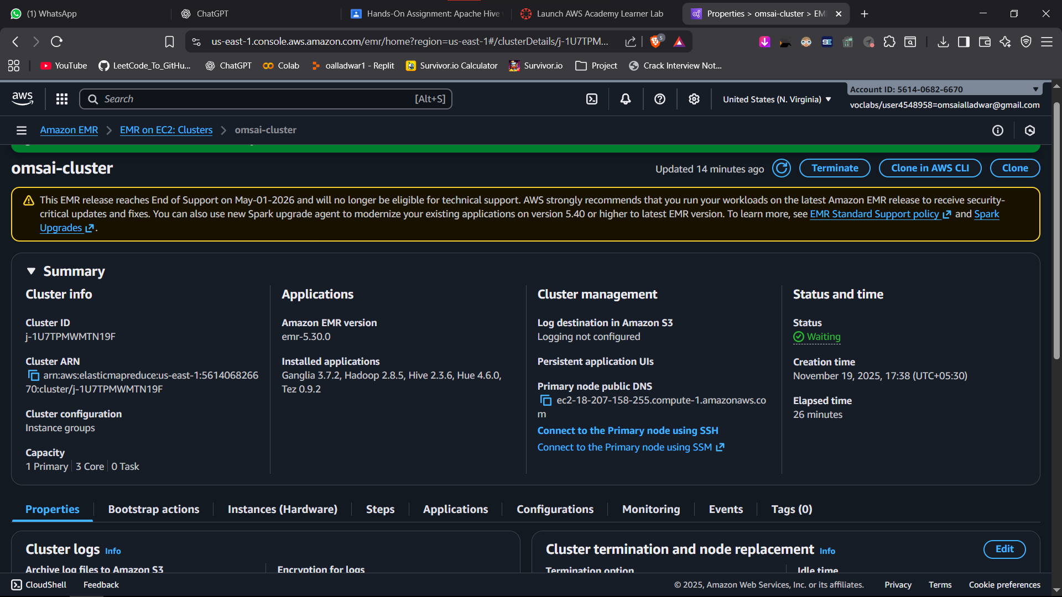

Connected to primary node on mobaxterm
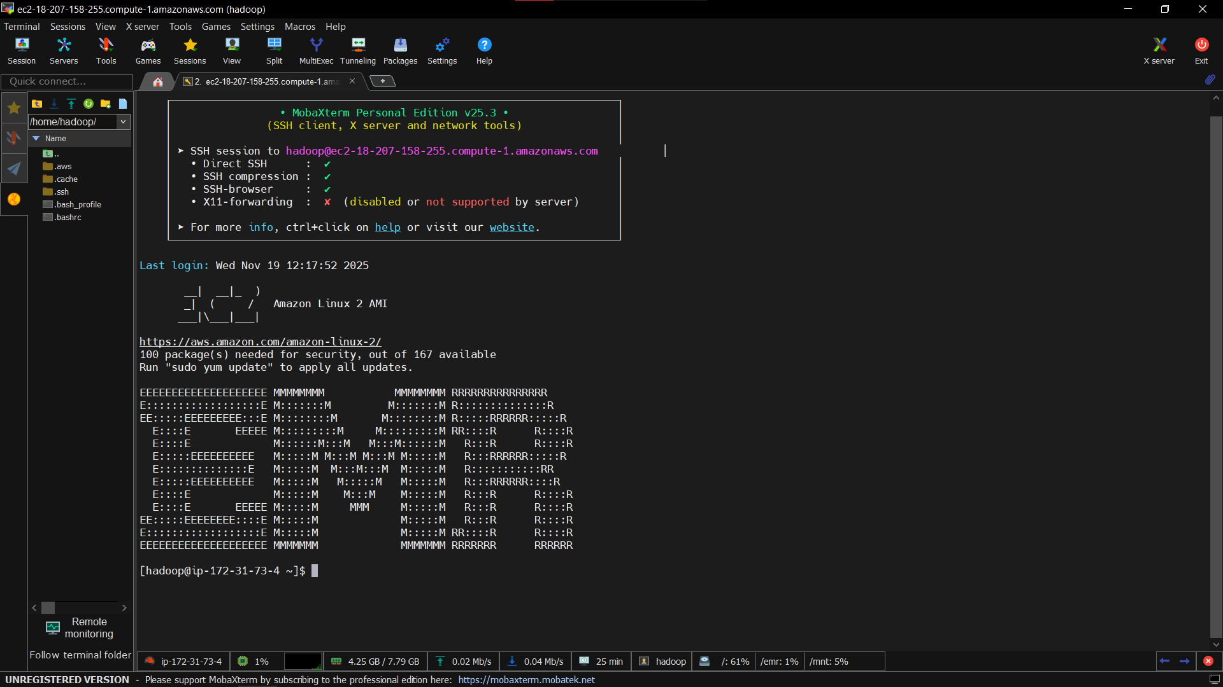

Uploaded adult.data file on primary node
Created a folder data on /user/hadoop/
Uploaded adult.data into that data folder.

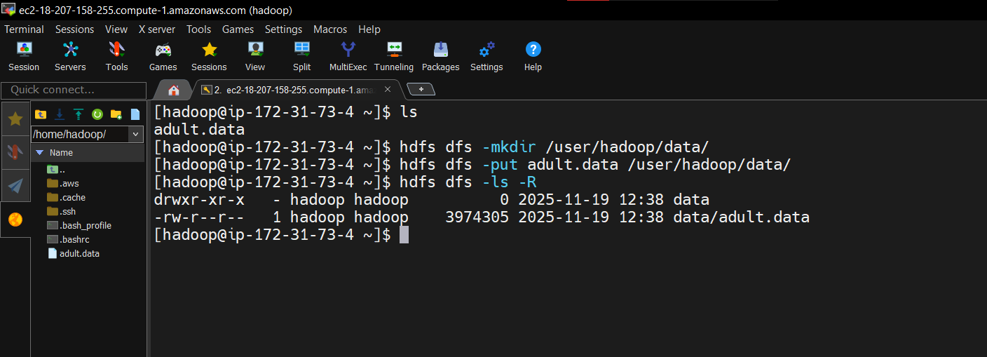

Created database omsai, used omsai database,
Created adult_managed managed table
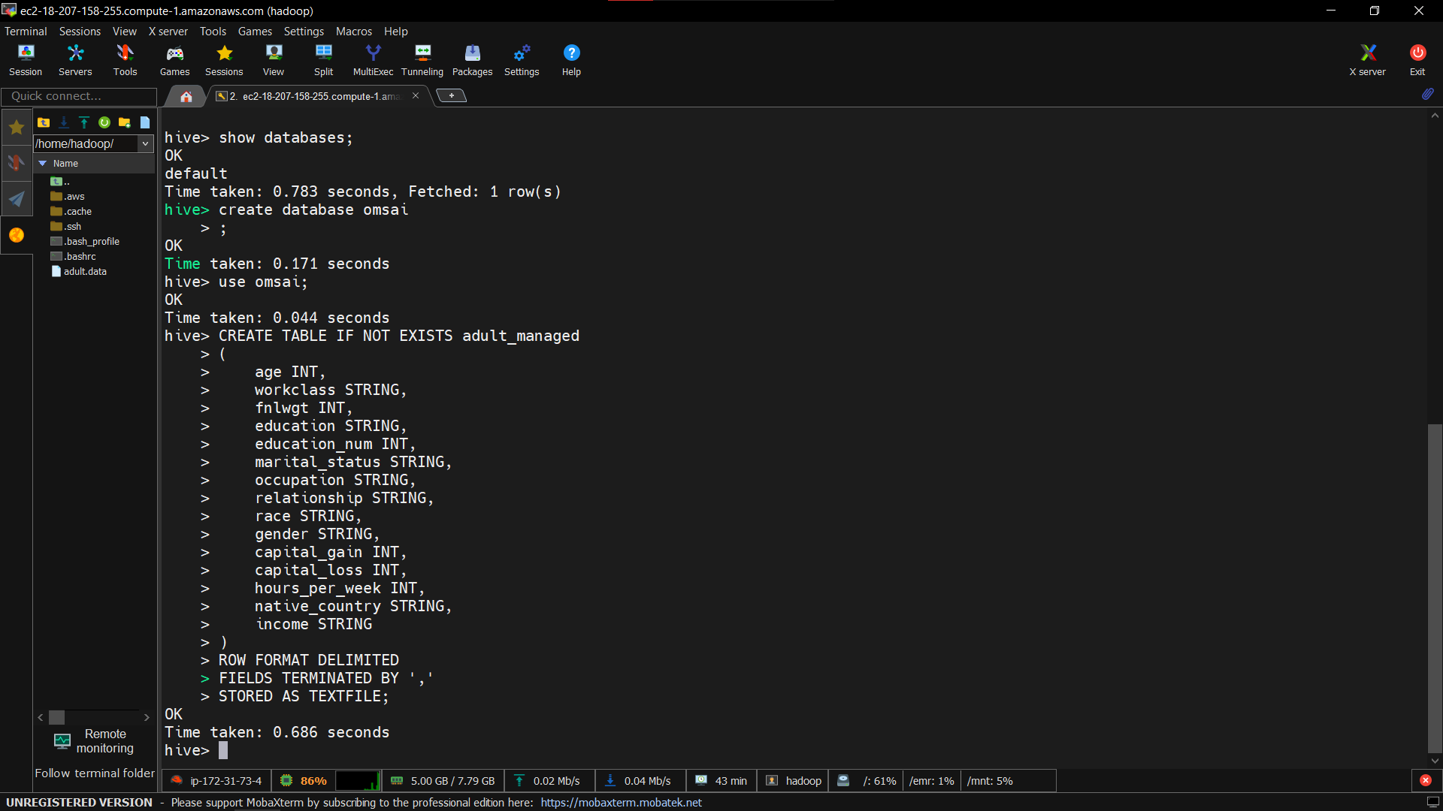

Created external table
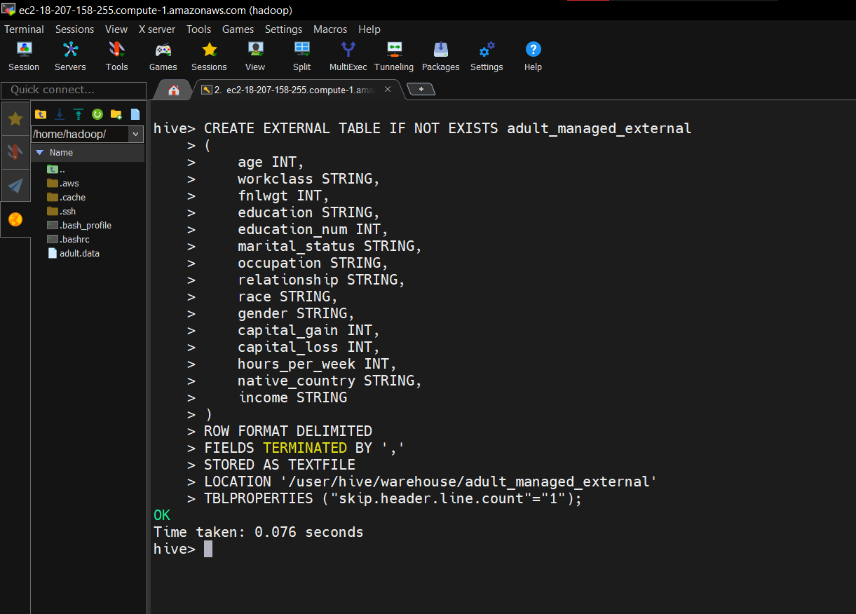

Loaded data into managed table
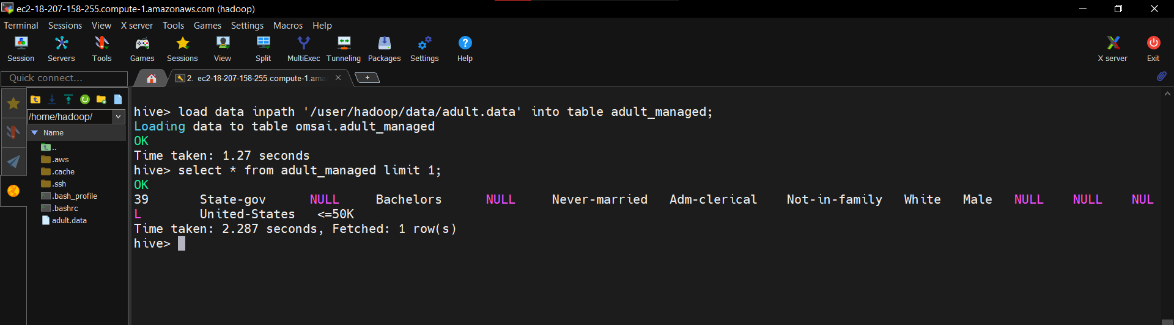

Before deleting data from hdfs, file is present in warehouse location :
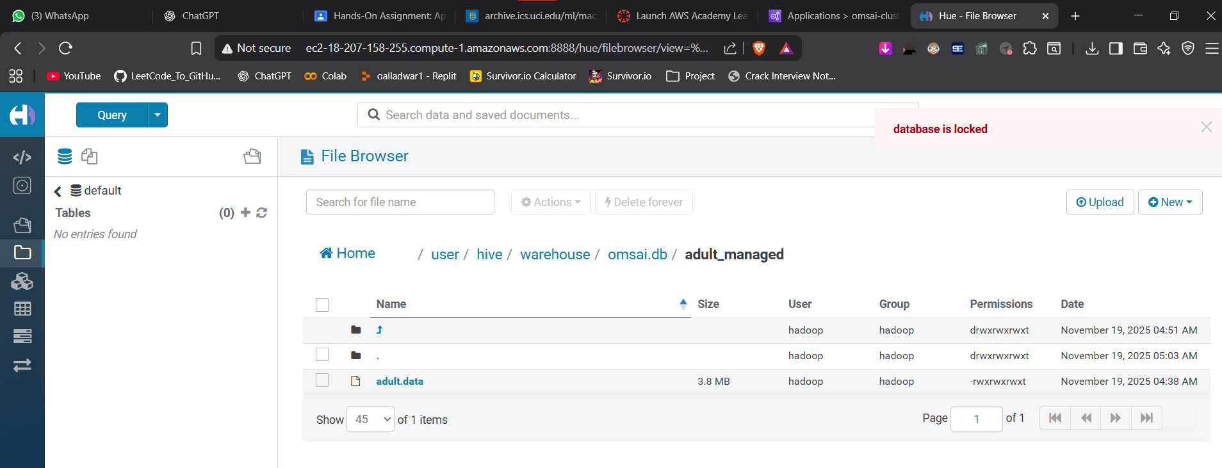

After deleting managed table file will be removed from warehouse location :
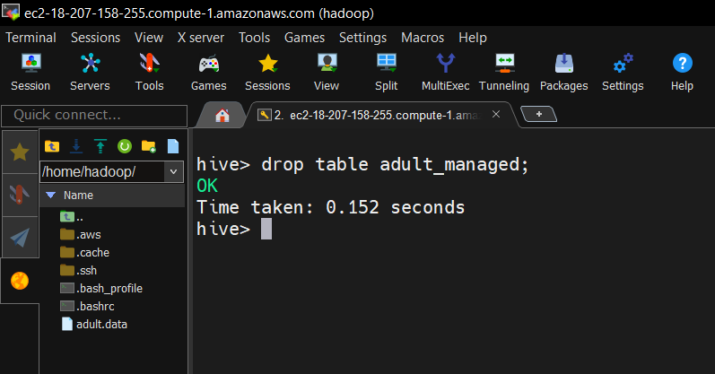
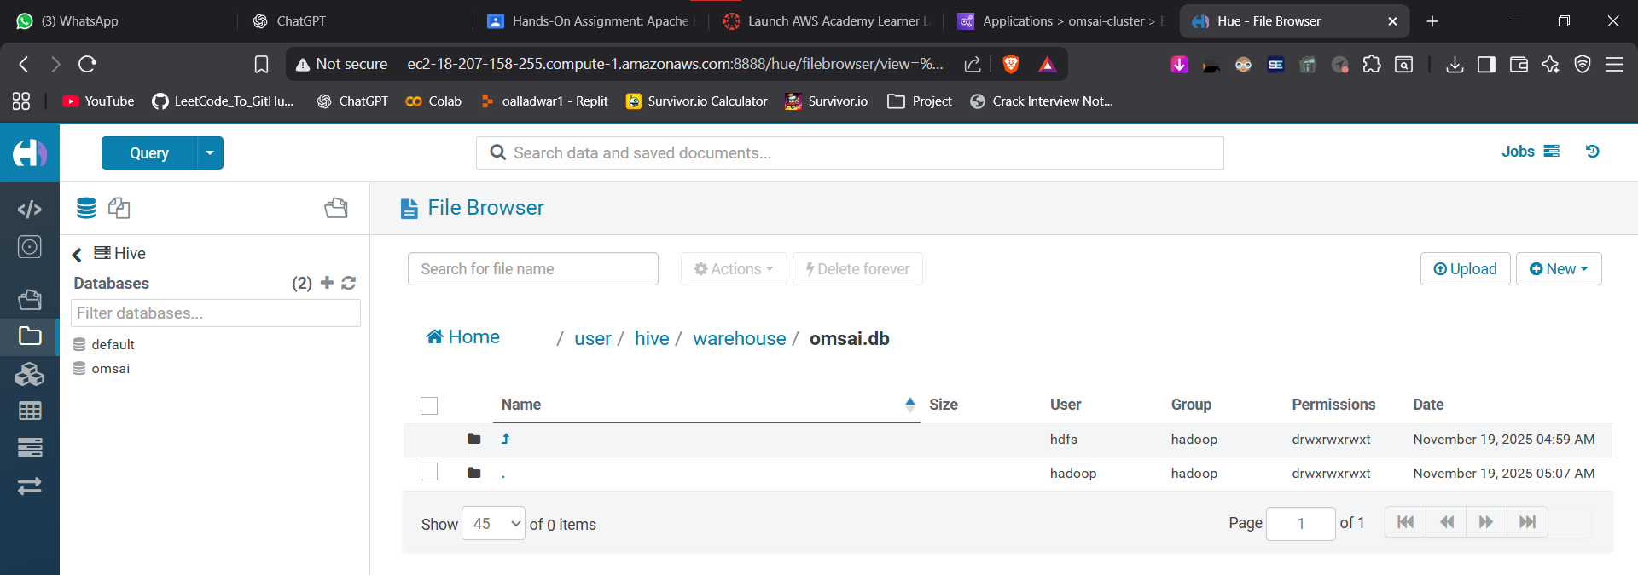

Deleted external table
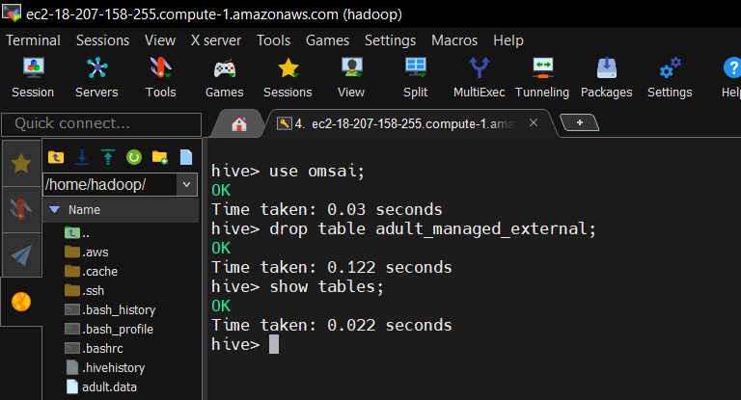

The adult.data file will not be present there because the managed table moved it to warehouse location and I did not reupload the adult.data file to /user/Hadoop/data
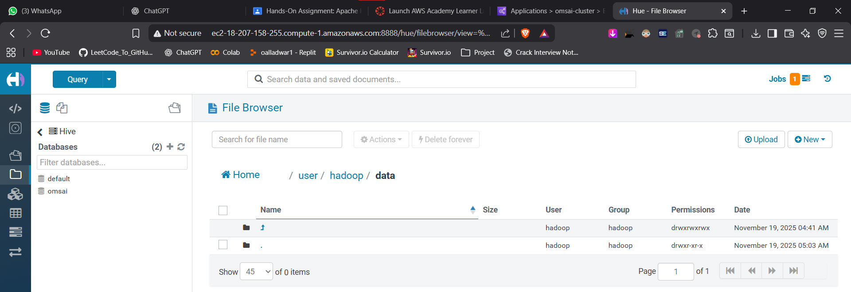

Re-uploaded adult.data file into hdfs
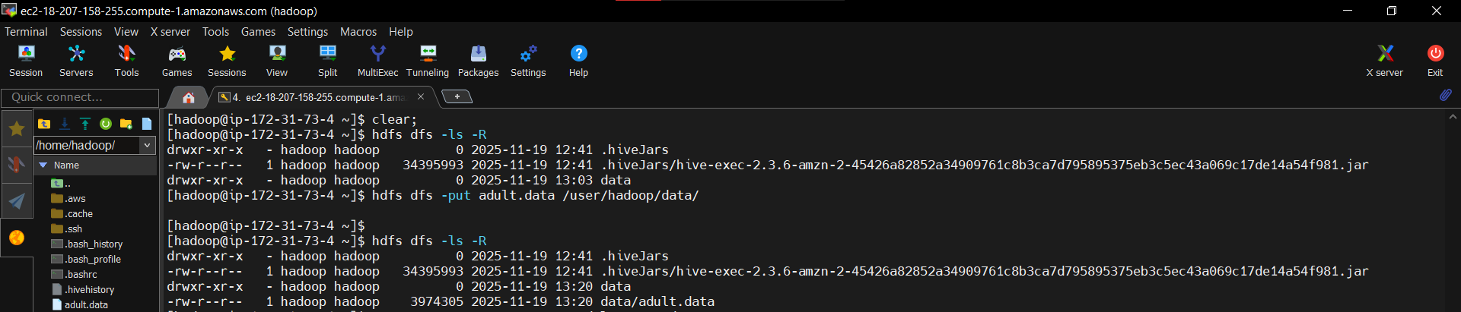

Recreated the internal table and loaded data into it.
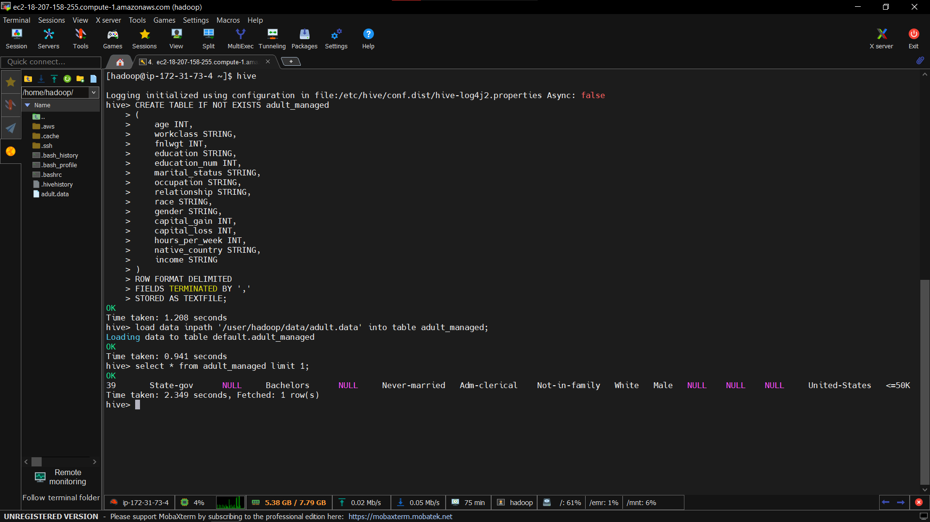

Ran Queries :
- Calculate the average age of all individuals.
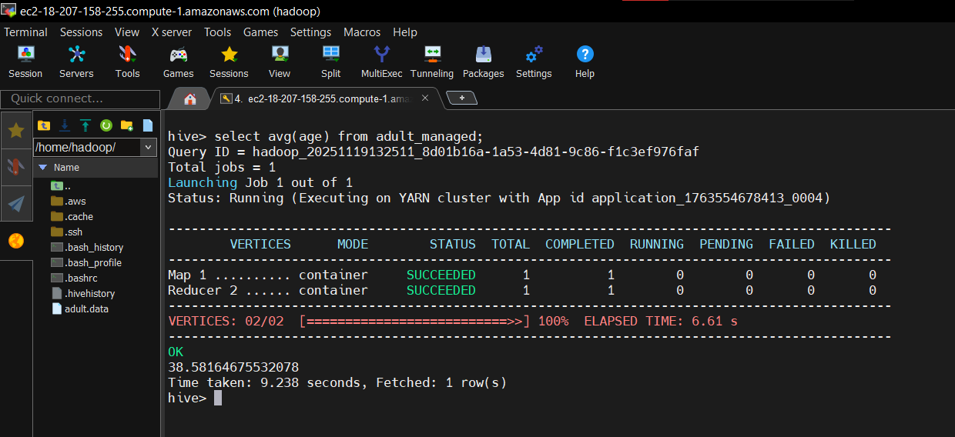

- Count individuals in each workclass, excluding missing values (' ?').
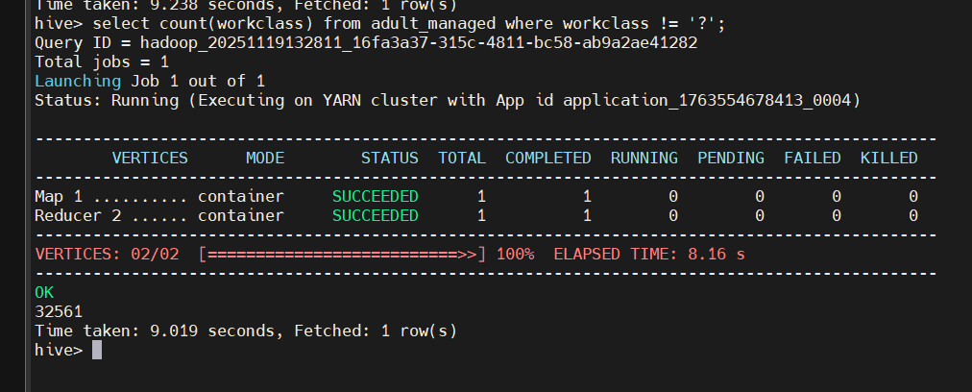

- Find the maximum and minimum age.
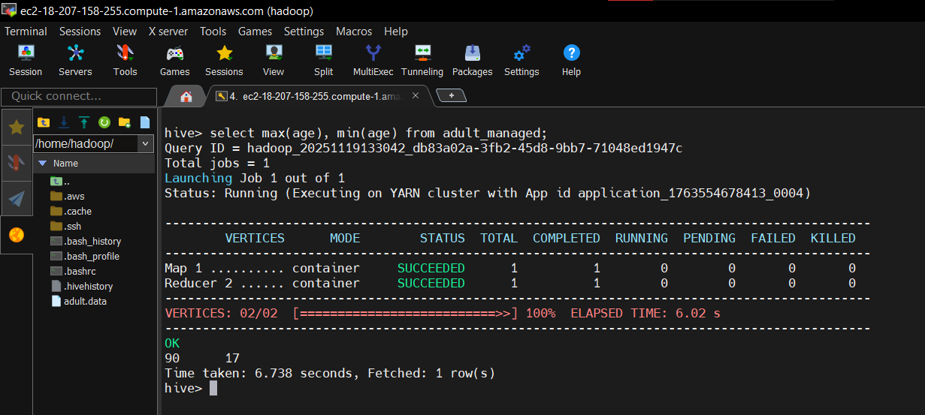

- Percentage of individuals with income '>50K'.
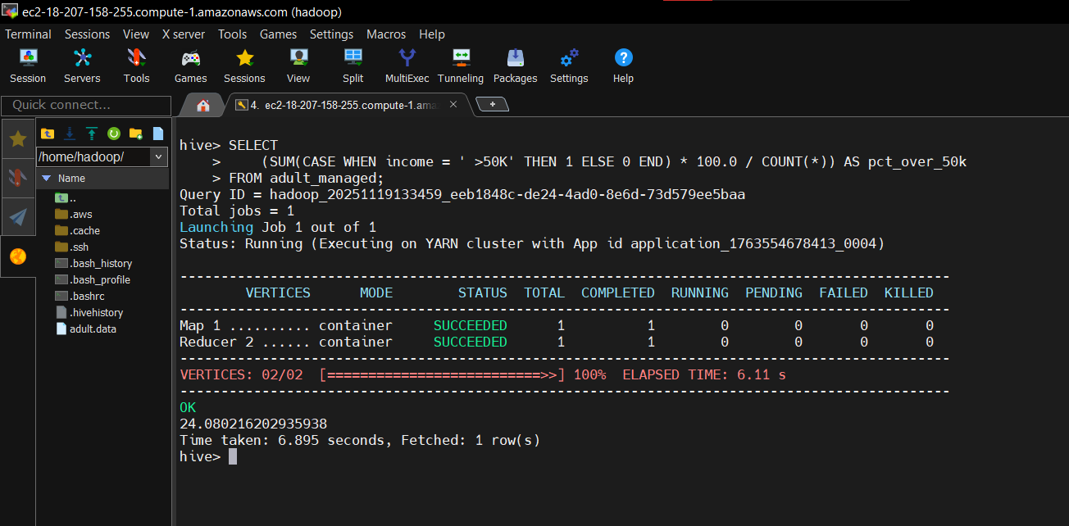

- Top 5 occupations by highest average hours-per-week (excluding '?')
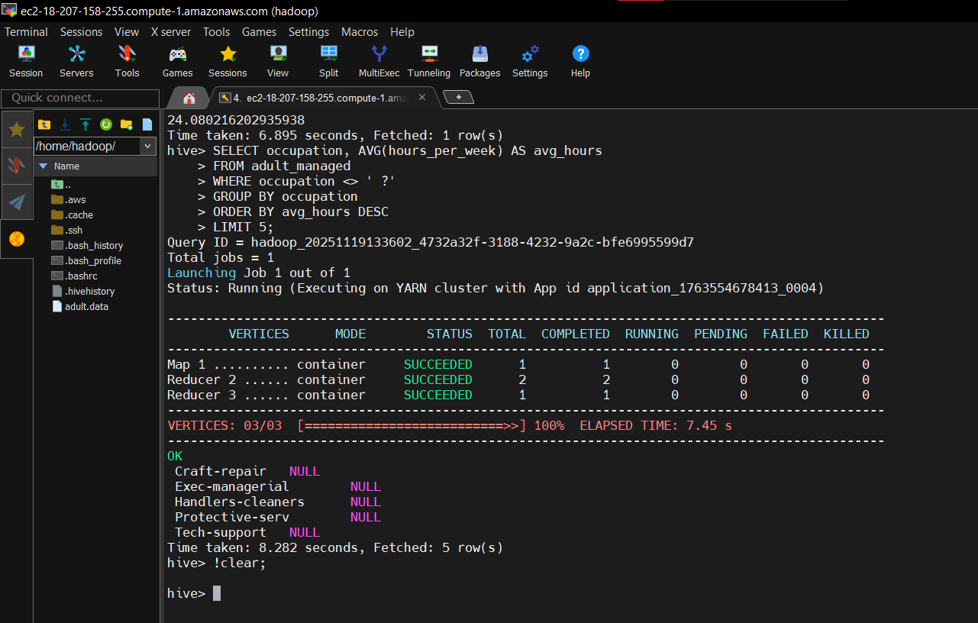

- Most common education level
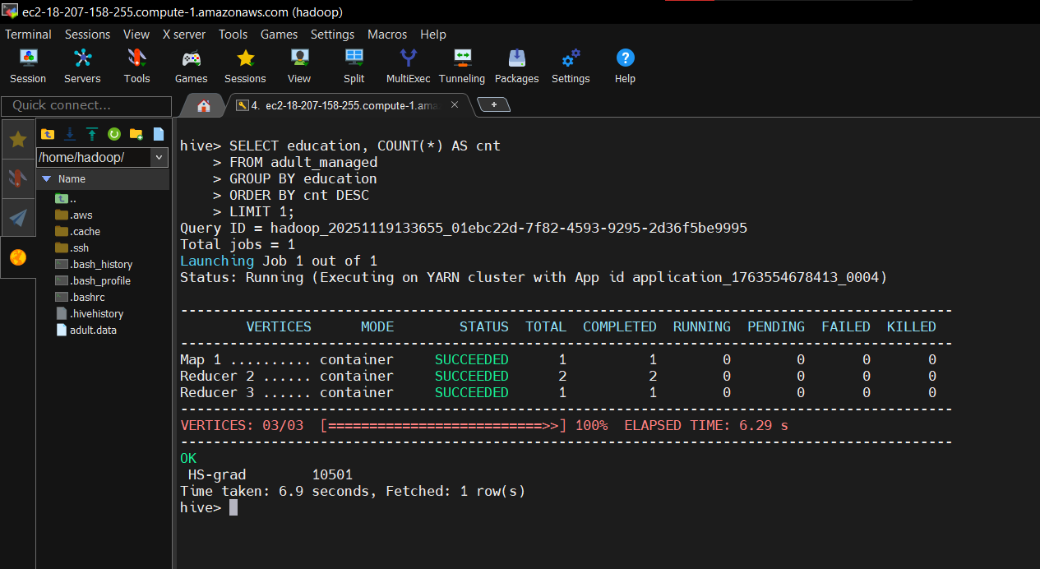

- Count married + bachelor’s degree
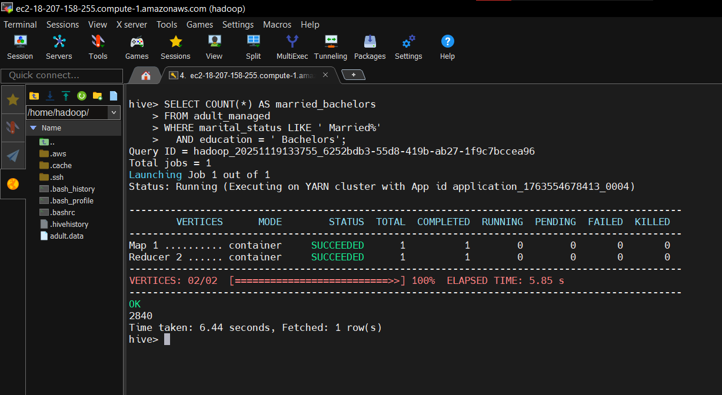

- Average age by race and Gender
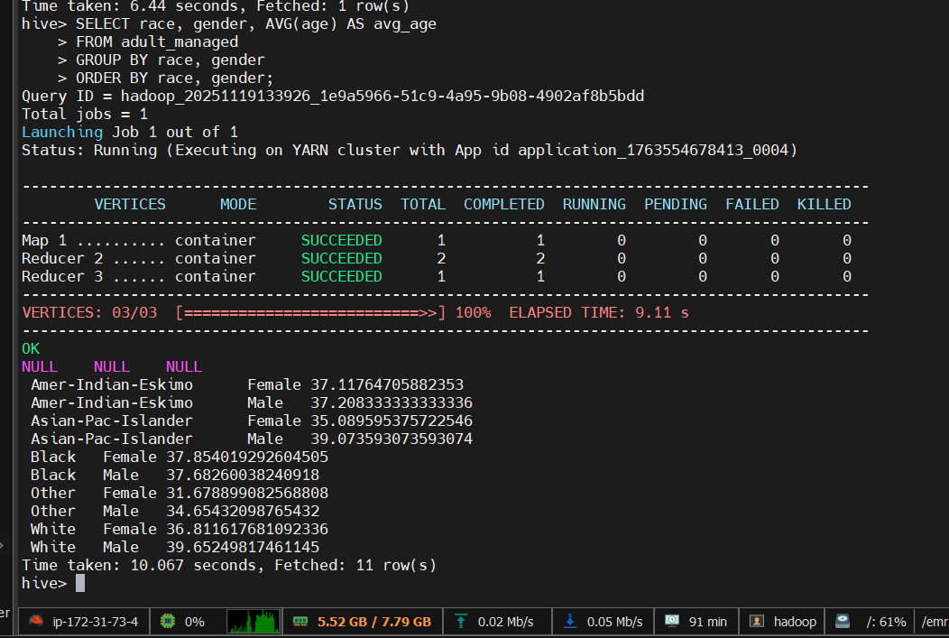

- Occupation with highest percentage of '>50K' (excluding '?')
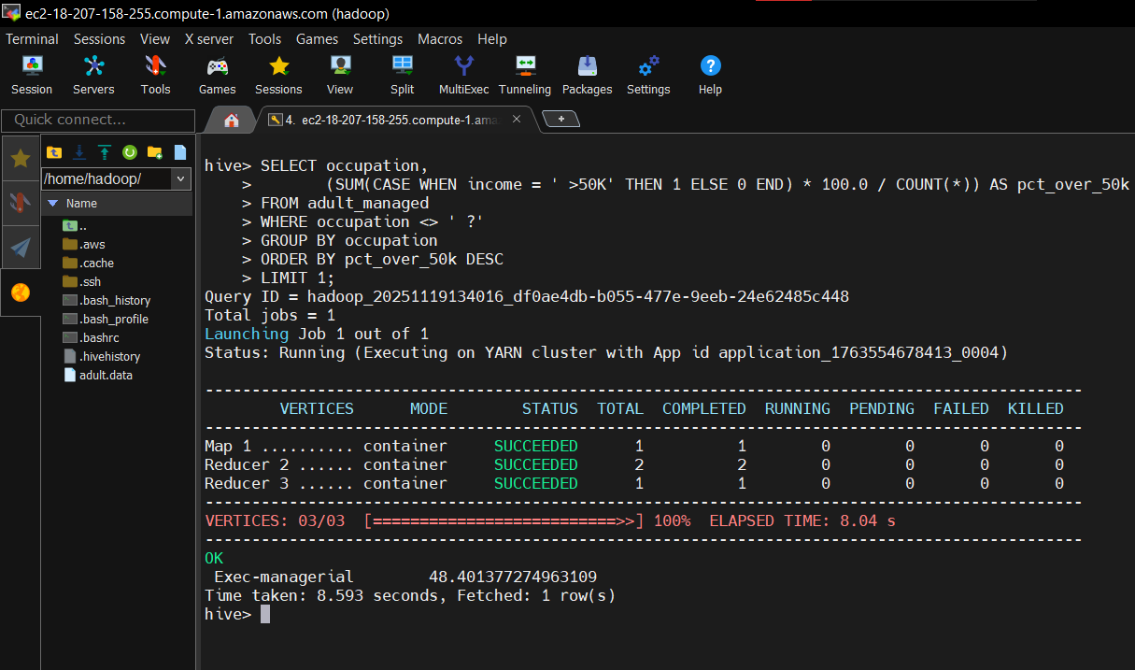

- Rank occupations by number of individuals (excluding '?')
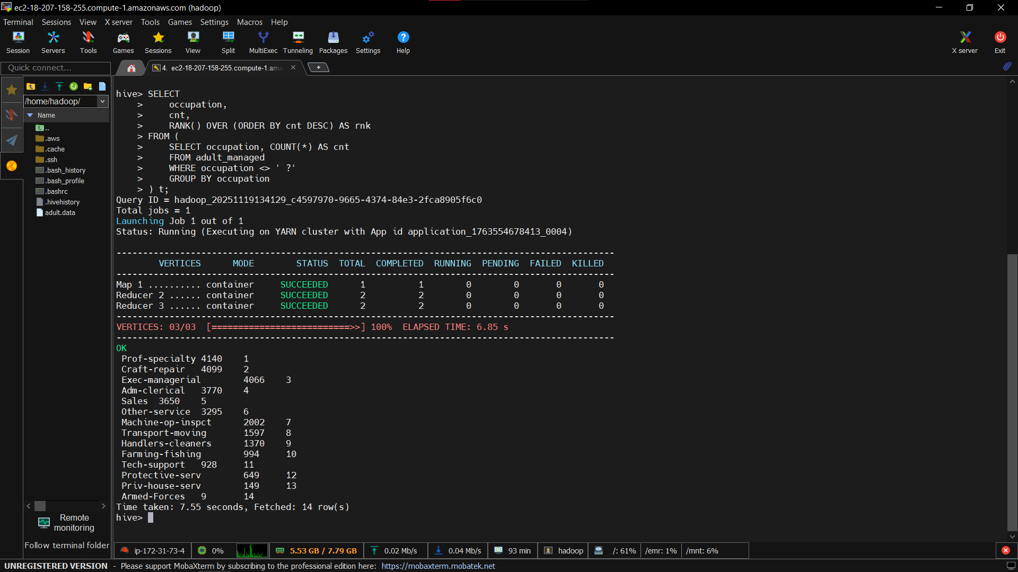

- 90th percentile of age
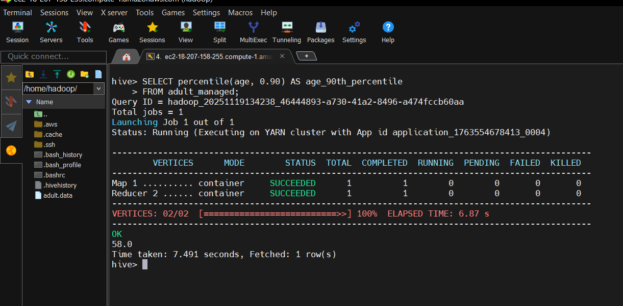

- Count individuals working >40 hrs and income <=50K
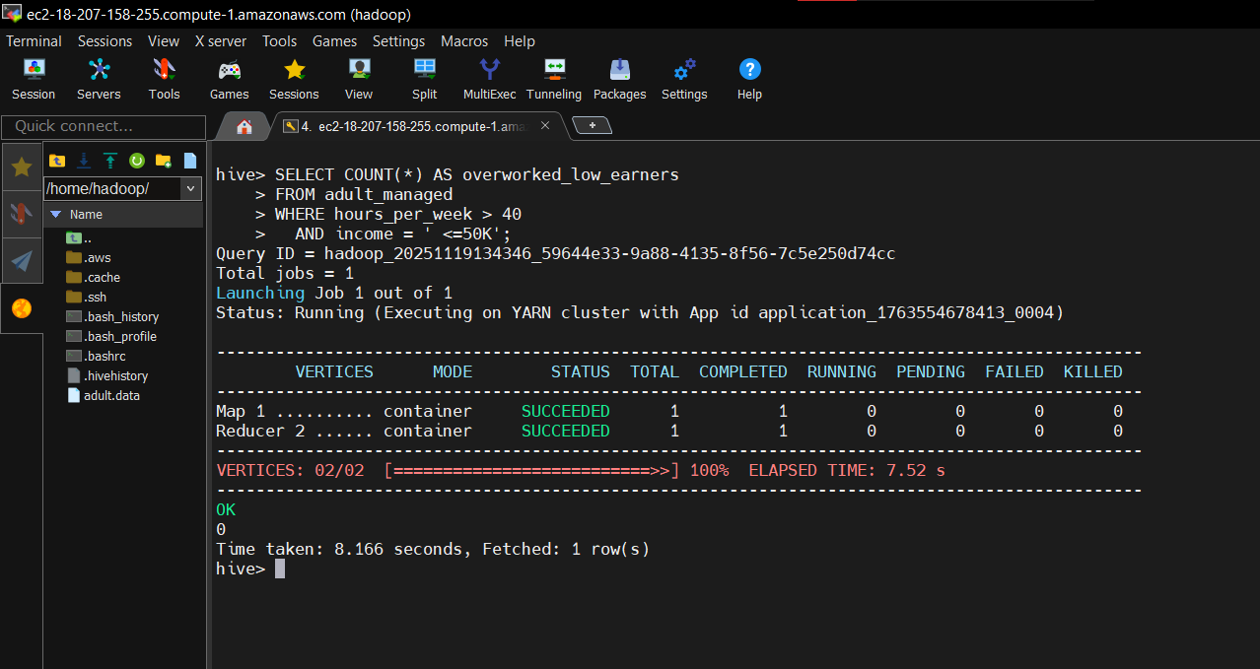

- Count individuals older than the average age (subquery)

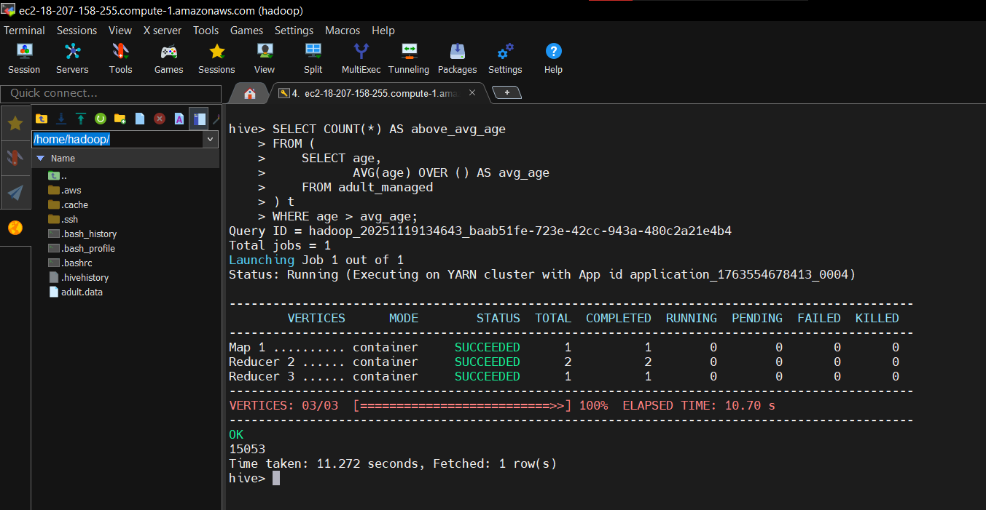

- Gender vs Income breakdown
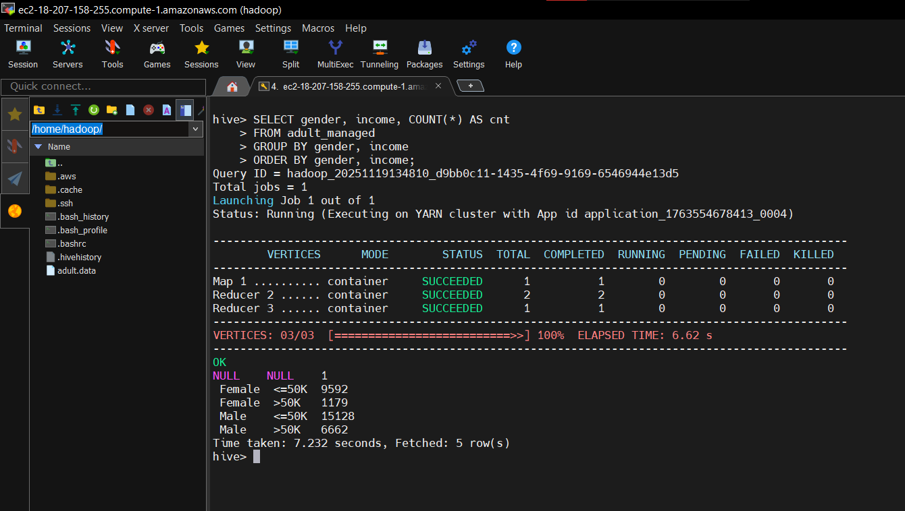

- Top 3 education levels by average age (CTE)
